A NAPT Proxy for Vulnerability Scanners based on Cloud

A Project Report

submitted in partial fulfillment of the

requirements for the award of the degree of

MASTER OF COMPUTER APPLICATION

DEPARTMENT OF COMPUTER APPLICATION
Submitted By

N.S

Under the Esteemed Guidance
of

Ms. A. ANURADHA
ASSISTANT PROFESSOR


Department of Computer Applications
DVR & Dr.HS
MIC College of Technology
(Autonomous)
Kanchikacherla– 521180, NTR Dist., Andhra Pradesh
April, 2025

DECLARATION

Im here by declare that, the work contains in this report is original and has been done by me under the guidance of our supervisor(s). The work has not been submitted to any other Institute for obtaining any degree or diploma. I have followed the guidelines provided by the Institute in preparing the report. I have conformed to the norms and guidelines given in the Ethical Code of Conduct of the Institute. Whenever I have used materials (data, theoretical analysis, figures, and text) from other sources, I have given due credit to them by citing in the text of report and giving their details in the references.

Place:

Date:
N.SURESH BABU
(23H71F0034)

CERTIFICATE

This is to certify that the project report entitled “A NAPT Proxy for Vulnerability Scanners Based on Cloud”submitted by N.SURESH BABU(23H71F0034) to the DVR & Dr. HS MIC College of Technology in partial fulfillment of the requirements for the award of the Degree of Master of Computer Application in is a bonafide record of work. The contents of this report, in full or in parts, have not been submitted to any other Institute for the award of any Degree.

Supervisor Head of the Department

Principal

Internal Examiner External Examiner

ACKNOWLEDGEMENT

I Would like to take this opportunity to express my deepest appreciation to the following people for their valuable contributions and assistance with this project.
Initially, I Would like to thank my project supervisor, MS. A. Anuradha, Assistant Professor, Department of Computer Applications for the guidance and support, especially for the valuable ideas and Knowledge Shared to me throughout the project.
I have the immense pleasure in expressing my thanks and deep sense of gratitude to, Mrs. A. Anuradha, Head, Department of Computer Applications for extending necessary facilities and support for the completion of the project.

I am thankful to my project coordinator Mr. K. Mahanthi, Assistant Professor, Department of Computer Applications for their internal Support an professionalism who helped me in shaping the project in to successful one.

I sincerely acknowledge Dr. K. Srinivas, Principal and Professor, D. PANDU RANGA RAO, CEO for giving opportunity to take up the Project work. I am also extend my thanks to all faculty members of Computer Applications, for their valuable guidance and encouragement.

Finally, my special thanks go to my family for their continuous support and help throughout my academic years and for their continual support and encouragement for the completion of the project.

CONTENTS

TITLE PAGE 1

DECLARATION 2

CERTIFICATE 3

ACKNOWLEDGEMENT 4

CONTENTS 5

ABSRACT 7

CHAPTER-1 : INTRODUCTION 9 – 14
  - 1.1 SYSTEM OVERVIEW

CHAPTER-2 : SYSTEM STUDY AND ANALTSIS 15 - 22
      - 2.1 INTRODUCTION
      - 2.2 EXISTING SYSTEM
2.2.1Disadvantages of Existing System
      - 2.3 PROPOSED SYSTEM
2.3.1 Advantages of Proposed System
      - 2.4 FEASIBILITY STUDY
• 2.4.1 Technical feasibility
• 2.4.2 Economic feasibility
• 2.4.3 Operational feasibility
      - 2.5 REQUIREMENT ANALYSIS
• 2.5.1 Fundamental Requirements
• 2.5.2 Non-functional requirements

CHAPTER-3 : DEVELOPMENT ENVIRONMENT 23-40

3.1 USER REQUIREMENTS
- 3.1.1 Software Requirements
- 3.1.2 Hardware Requirements
3.2 PROGRAMING ENVIRONMENT

CHAPTER – 4 : DESIGN AND DEVELOPMENT 41-59
- 4.1 INTRODUCTION
- 4.2 SPIRAL MODEL
- 4.3 DATABASE AND TABLES
- 4.4 DATA MODELING
- 4.5 MODULES
CHAPTER – 5 : TESTING AND VALIDATION 60-78
5.1 TYPES OF TESTING
5.1 TYPES OF TESTS
CHAPTER-6: CONCLUSION AND FEATURE ENHANCEMENT 79-80
CHAPTER-7:BIBILOGRAPHY AND REFERENCES 81-83

ABSTRACT
The rapid adoption of cloud computing has revolutionized the way organizations manage their IT infrastructure and security. One of the key advancements in this domain is the emergence of Security-as-a-Service (SaaS), an outsourcing model that allows organizations to leverage cloud-based solutions for security management. Among the various applications of SaaS, vulnerability scanners have gained significant traction due to their pay-per-use model and powerful scanning capabilities. These scanners enable organizations to identify and mitigate security vulnerabilities in their systems efficiently. However, deploying vulnerability scanners in cloud environments presents unique challenges. When performing vulnerability scans over a network, the scanner must establish a large number of TCP connections with the target hosts. In most organizational setups, these target hosts are deployed behind NAPT (Network Address and Port Translation) devices to address the IPv4 address shortage and to protect internal networks. While NAPT devices provide security and address conservation benefits, they also block external TCP connections, rendering cloud-based vulnerability scanners ineffective. To address this challenge, we propose Cloud Proxy, a NAPT proxy specifically designed for vulnerability scanners in cloud computing environments. Cloud Proxy combines the TURN (Traversal Using Relays around NAT) extension protocol and the Socks5 protocol to enable transparent packet relaying. By integrating the functionality of Socks5 into the TURN client, Cloud Proxy aggregates the destination ports of scanning packets before they pass through the TURN server.

INTRODUCTION
  - SYSTEM OVERVIEW
What is cloud computing?
Cloud computing is the use of computing resources (hardware and software) that are delivered as a service over a network (typically the Internet). The name comes from the common use of a cloud-shaped symbol as an abstraction for the complex infrastructure it contains in system diagrams. Cloud computing entrusts remote services with a user's data, software and computation. Cloud computing consists of hardware and software resources made available on the Internet as managed third-party services. These services typically provide access to advanced software applications and high-end networks of server computers.
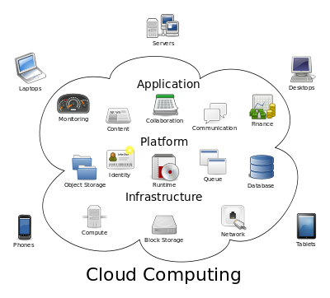
Fig 1.1 Structure of cloud computing
How Cloud Computing Works?
The goal of cloud computing is to apply traditional supercomputing, or high-performance computing power, normally used by military and research facilities, to perform tens of trillions of computations per second, in consumer-oriented applications such as financial portfolios, to deliver personalized information, to provide data storage or to power large, immersive computer games.
The cloud computing uses networks of large groups of servers typically running low-cost consumer PC technology with specialized connections to spread data-processing chores across them. This shared IT infrastructure contains large pools of systems that are linked together. Often, virtualization techniques are used to maximize the power of cloud computing.
Characteristics and Services Models:
The salient characteristics of cloud computing based on the definitions provided by the National Institute of Standards and Terminology (NIST) are outlined below:
- On-demand self-service: A consumer can unilaterally provision computing capabilities, such as server time and network storage, as needed automatically without requiring human interaction with each service’s provider.
- Broad network access: Capabilities are available over the network and accessed through standard mechanisms that promote use by heterogeneous thin or thick client platforms (e.g., mobile phones, laptops, and PDAs).
- Resource pooling: The provider’s computing resources are pooled to serve multiple consumers using a multi-tenant model, with different physical and virtual resources dynamically assigned and reassigned according to consumer demand. There is a sense of location-independence in that the customer generally has no control or knowledge over the exact location of the provided resources but may be able to specify location at a higher level of abstraction (e.g., country, state, or data center). Examples of resources include storage, processing, memory, network bandwidth, and virtual machines.
- Rapid elasticity: Capabilities can be rapidly and elastically provisioned, in some cases automatically, to quickly scale out and rapidly released to quickly scale in. To the consumer, the capabilities available for provisioning often appear to be unlimited and can be purchased in any quantity at any time.
- Measured service: Cloud systems automatically control and optimize resource use by leveraging a metering capability at some level of abstraction appropriate to the type of service (e.g., storage, processing, bandwidth, and active user accounts). Resource usage can be managed, controlled, and reported providing transparency for both the provider and consumer of the utilized service.
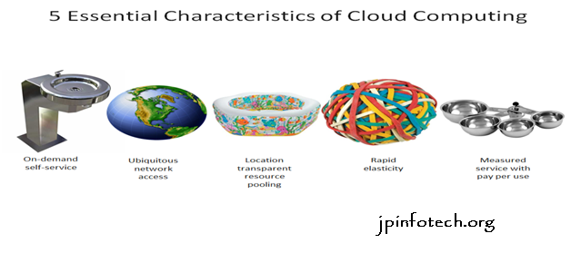
Fig 1.2 Characteristics of cloud computing
Services Models:
Cloud Computing comprises three different service models, namely Infrastructure-as-a-Service (IaaS), Platform-as-a-Service (PaaS), and Software-as-a-Service (SaaS). The three service models or layer are completed by an end user layer that encapsulates the end user perspective on cloud services. The model is shown in figure below. If a cloud user accesses services on the infrastructure layer, for instance, she can run her own applications on the resources of a cloud infrastructure and remain responsible for the support, maintenance, and security of these applications herself. If she accesses a service on the application layer, these tasks are normally taken care of by the cloud service provider.
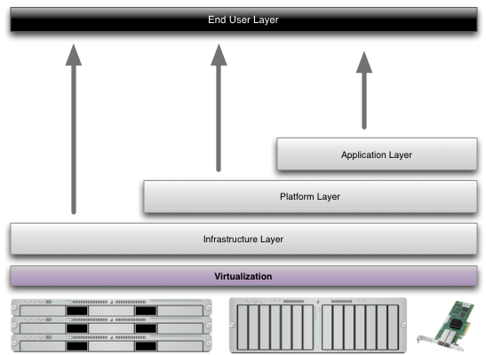
Fig 1.3 Structure of service models
Benefits of cloud computing:
- Achieve economies of scale – increase volume output or productivity with fewer people. Your cost per unit, project or product plummets.
- Reduce spending on technology infrastructure. Maintain easy access to your information with minimal upfront spending. Pay as you go (weekly, quarterly or yearly), based on demand.
- Globalize your workforce on the cheap. People worldwide can access the cloud, provided they have an Internet connection.
- Streamline processes. Get more work done in less time with less people.
- Reduce capital costs. There’s no need to spend big money on hardware, software or licensing fees.
- Improve accessibility. You have access anytime, anywhere, making your life so much easier!
- Monitor projects more effectively. Stay within budget and ahead of completion cycle times.
- Less personnel training is needed. It takes fewer people to do more work on a cloud, with a minimal learning curve on hardware and software issues.
- Minimize licensing new software. Stretch and grow without the need to buy expensive software licenses or programs.
- Improve flexibility. You can change direction without serious “people” or “financial” issues at stake.
Advantages:
- Price: Pay for only the resources used.
- Security: Cloud instances are isolated in the network from other instances for improved security.
- Performance: Instances can be added instantly for improved performance. Clients have access to the total resources of the Cloud’s core hardware.
- Scalability: Auto-deploy cloud instances when needed.
- Uptime: Uses multiple servers for maximum redundancies. In case of server failure, instances can be automatically created on another server.
- Control: Able to login from any location. Server snapshot and a software library lets you deploy custom instances.
- Traffic: Deals with spike in traffic with quick deployment of additional instances to handle the load.

SYSTEM STUDY AND ANALYSIS
2.1 INTRODUCTION
After analysing the requirements of the task to be performed, the next step is to analyse the problem and understand its context. The first activity in the phase is studying the existing system and other is to understand the requirements and domain of the new system. Both the activities are equally important, but the first activity serves as a basis of giving the fundamental specifications and then successful design of the proposed system. Understanding the properties and requirements of a new system is more difficult and requires creative thinking and understanding of existing running system is difficult, improper understanding of the present system can lead diversion from solution.
2.2. EXISTING SYSTEM:
- In traditional systems, vulnerability scanners are deployed in cloud computing environments to assess the security of target hosts. These scanners typically establish numerous TCP connections to carry out the scanning process, sending packets over the network to identify vulnerabilities. However, several challenges arise in this setup, especially in scenarios involving NAPT (Network Address and Port Translation) devices, which are commonly used to protect internal networks.
- NAPT Device Interference: NAPT devices are used to map private IP addresses to public IP addresses. This creates a challenge for vulnerability scanners because any outgoing TCP packets from the scanner may be blocked by the NAPT device, preventing successful communication between the scanner and the target hosts.
- Poor TCP Support in NAPT Traversal: While NAPT traversal methods exist, most of them support UDP traffic well but are inadequate for handling the numerous TCP connections required by vulnerability scanners in cloud computing environments.
- Lack of Seamless Integration: There is no direct or efficient mechanism for ensuring vulnerability scanning tools can function smoothly through NAPT or other network address translation methods, leading to unreliable and incomplete vulnerability scans.
2.2.1. Disadvantages Of Existing System:
Inability to Complete Scanning Tasks:
NAPT Device Interference: Since NAPT devices map private IP addresses to public ones, they can block outgoing TCP packets from the vulnerability scanner.
Ineffective NAPT Traversal for TCP Traffic:
Poor TCP Support: Most NAPT traversal methods are optimized for UDP traffic, not TCP. Given that vulnerability scanners rely on establishing numerous TCP connections to carry out scans, existing traversal methods struggle to accommodate the volume and complexity of TCP traffic.
Performance Degradation:
High Latency and Packet Loss: Due to inefficient traversal of NAPT devices and poor support for TCP, the process of relaying packets through the network becomes slower.
2.3PROPESED SYSTEM:
To address the above challenges, the proposed system introduces Cloud Proxy, a NAPT proxy designed to allow vulnerability scanners to operate effectively in cloud environments despite NAPT-related limitations. Cloud Proxy is built by combining the TURN extension protocol and the Socks5 protocol, creating a solution that can efficiently relay scanning packets through NAPT devices.
1TURN Protocol:
1.Facilitates packet relaying through NAT devices by acting as an intermediary server.
2.Ensures that packets from the vulnerability scanner reach the target host behind the NAPT device.
Socks5 Protocol:
1.Provides a proxy layer for handling TCP connections.
2.Integrated into the TURN client to aggregate scanning packets and reduce the load on the TURN server.
TURN Client with Socks5 Integration:
1.Combines the functionality of Socks5 and TURN to optimize packet handling
2.Aggregates destination ports of scanning packets before relaying them to the TURN server.

2.3.1. Advantages Of Proposed System:
NAPT Traversal for TCP Connections:
1.Enables vulnerability scanners to establish TCP connections with targets behind NAPT devices, overcoming the limitations of existing NAPT traversal methods.
Transparent Packet Relaying:
1.Ensures that scanning packets are relayed seamlessly without requiring changes to the target host or the scanner.
Scalability:
1.Handles a large number of TCP connections efficiently, making it suitable for real-world vulnerability scanning scenarios.
Reduced TURN Server Load:
1.By aggregating packets at the
2.4 FEASIBILITY STUDY
To manner studies and explores of an active and scientific nature and to encourage the conversation and enlargement of approaches and tools for operational analysis is useful to protection problems.
Feasibility study is accompanied once the difficult is obviously understood. The feasibility study which is a great level lozenge version of the whole system analysis and design procedure. The independent is to define whether the planned system is possible or not and it benefits us to the least expense of how to resolve the problem and to govern, if the Problem is wealth solving.
The following are the three important tests that have been conceded out for feasibilitystudy.
- Technical Feasibility
- Economic feasibility
- Operational feasibility
2.4.1 Technical feasibility
In the technical feasibility study, one has to assess whether the implemented system can be established using existing technology or not. It is intended to implement the implemented system in JSP. The project enabled is theoretically feasible since the following reasons.
- All needed technology exists to improve the system.
- The existing system is so malleable that it can be advanced further.
2.4.2 Economic feasibility
As a portion of this, the expenses and profits related with the implemented systems are to be associated. The project is carefully feasible only if tangible and intangible assistances balance the cost. We can say the implemented system is feasible founded on the following grounds.
- The charge of developing the filled system is sensible.
- The cost of hardware and software for the application is less.

2.4.3 Operational feasibility
This project is operationally feasible for there is necessary support from the project organization and the users of the implemented system .Implemented system absolutely does not damage and determination not create the corrupt results and no problem will ascend after implementation of the system.
2.5 REQUIREMENT ANALYSIS
2.5.1 Functional Requirements:
The model that is being followed is the SOFTWARE DEVELOPMENT LIFE CYCLE MODEL, which states that the phases are organised in order. First of all the feasibility study is done. Once that part is completed, the requirement analysis and project planning begins. If system exists once, then modifications and addition of new modules is needed, analysis of present system can be used as basic model.
The design starts after the requirement analysis is completed and the coding begins after the design is completed. Once the programming is completed, the testing is done. In this model the sequence of activities performed in a software development project are
- Project planning
- Requirement definition
- Design
- Development
- Integration and testing
- Installation and acceptance
INPUT DESIGN
The input design is the link between the information system and the user. It comprises the developing specification and procedures for data preparation and those steps are necessary to put transaction data in to a usable form for processing can be achieved by inspecting the computer to read data from a written or printed document or it can occur by having people keying the data directly into the system. The design of input focuses on controlling the amount of input required, controlling the errors, avoiding delay, avoiding extra steps and keeping the process simple. The input is designed in such a way so that it provides security and ease of use with retaining the privacy. Input Design considered the following things:
- What data should be given as input?
- How the data should be arranged or coded?
- The dialog to guide the operating personnel in providing input.
- Methods for preparing input validations and steps to follow when error occur.
OBJECTIVES
1.Input Design is the process of converting a user-oriented description of the input into a computer-based system. This design is important to avoid errors in the data input process and show the correct direction to the management for getting correct information from the computerized system.
2.It is achieved by creating user-friendly screens for the data entry to handle large volume of data. The goal of designing input is to make data entry easier and to be free from errors. The data entry screen is designed in such a way that all the data manipulates can be performed. It also provides record viewing facilities.
3.When the data is entered it will check for its validity. Data can be entered with the help of screens. Appropriate messages are provided as when needed so that the user
will not be in maize of instant. Thus the objective of input design is to create an input layout that is easy to follow
OUTPUT DESIGN
A quality output is one, which meets the requirements of the end user and presents the information clearly. In any system results of processing are communicated to the users and to other system through outputs. In output design it is determined how the information is to be displaced for immediate need and also the hard copy output. It is the most important and direct source information to the user. Efficient and intelligent output design improves the system’s relationship to help user decision-making.
1. Designing computer output should proceed in an organized, well thought out manner; the right output must be developed while ensuring that each output element is designed so that people will find the system can use easily and effectively. When analysis design computer output, they should Identify the specific output that is needed to meet the requirements.
2.Select methods for presenting information.
3.Create document, report, or other formats that contain information produced by the system.
The output form of an information system should accomplish one or more of the following objectives.
- Convey information about past activities, current status or projections of the
- Future.
- Signal important events, opportunities, problems, or warnings.
- Trigger an action.
- Confirm an action.

2.5.2 Non-functional requirements:
The major non-functional requirements of the system are as follows
User-friendly
Customer will use the forms for their various transactions i.e. for adding new routes, viewing the routes details. Also the Customer wants the reports to view the various transactions based on the constraints. These forms and reports are generated as user-friendly to the Client.
Reliability
The package wills pick-up current transactions on line. Regarding the old transactions, User will enter them in to the system.
Security
The web server and database server should be protected from hacking, virus etc.
Security is freedom from, or resilience against, potential harm caused by others. Beneficiaries of security may be of persons and social groups, objects and institutions, ecosystems or any other entity or phenomenon vulnerable to unwanted change by its environment.
Availability
This software will be available always.High availability software is software used to ensure that systems are running and available most of the time. High availability is a high percentage of time that the system is functioning. It can be formally defined as

CHAPTER III

DEVELOPMENT ENVIRONMENT
3.1 User Requirements
Requirement Specification plays an important role to create quality software solution. Requirements are refined and analysed to assess the clarity. Requirements are represented in a manner that ultimately leads to successful software implementation. Each requirement must be consistent with the overall objective.
3.1.1 Software Requirements
The software requirements specification is produced at the end of the analysis task. Software requirement is a difficult task, only decided after testing whether it fits the requirements.
- Operating System - Windows XP
- Coding Language - Java/J2EE
- Front End - J2EE
- Back End - MySQL

3.1.2 Hardware Requirements
This is an java project so hardware plays an important role. Selection of hardware also plays an important role in existence and performance of any software. The size and capacity are main requirements.
- Processor - Pentium –IV
- RAM - 4 GB (min)
- Hard Disk - 20 GB
- Key Board - Standard Windows Keyboard
- Mouse - Two or Three Button Mouse
- Monitor - SVGA

3.2 PROGRAMING ENVIRONMENT

Java Technology
Java technology is both a programming language and a platform.

The Java Programming Language

The Java programming language is a high-level language that can be characterized by all of the following buzzwords:
    - Simple
    - Architecture neutral
    - Object oriented
    - Portable
    - Distributed
    - High performance
    - Interpreted
    - Multithreaded
    - Robust
    - Dynamic
    - Secure
With most programming languages, you either compile or interpret a program so that you can run it on your computer. The Java programming language is unusual in that a program is both compiled and interpreted. With the compiler, first you translate a program into an intermediate language called Java byte codes —the platform-independent codes interpreted by the interpreter on the Java platform. The interpreter parses and runs each Java byte code instruction on the computer. Compilation happens just once; interpretation occurs each time the program is executed. The following figure illustrates how this works.

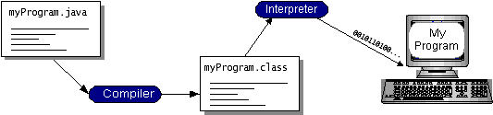
Fig 3.1 java programing
You can think of Java byte codes as the machine code instructions for the Java Virtual Machine (Java VM). Every Java interpreter, whether it’s a development tool or a Web browser that can run applets, is an implementation of the Java VM. Java byte codes help make “write once, run anywhere” possible. You can compile your program into byte codes on any platform that has a Java compiler. The byte codes can then be run on any implementation of the Java VM. That means that as long as a computer has a Java VM, the same program written in the Java programming language can run on Windows 2000, a Solaris workstation, or on an iMac.

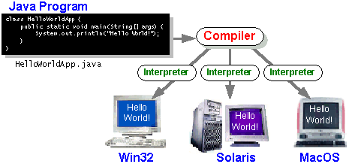

Fig 3.2 java program

The Java Platform
A platform is the hardware or software environment in which a program runs. We’ve already mentioned some of the most popular platforms like Windows 2000, Linux, Solaris, and MacOS. Most platforms can be described as a combination of the operating system and hardware. The Java platform differs from most other platforms in that it’s a software-only platform that runs on top of other hardware-based platforms.
The Java platform has two components:
- The Java Virtual Machine (Java VM)
- The Java Application Programming Interface (Java API)
You’ve already been introduced to the Java VM. It’s the base for the Java platform and is ported onto various hardware-based platforms.
The Java API is a large collection of ready-made software components that provide many useful capabilities, such as graphical user interface (GUI) widgets. The Java API is grouped into libraries of related classes and interfaces; these libraries are known as packages. The next section, What Can Java Technology Do? Highlights what functionality some of the packages in the Java API provide.
The following figure depicts a program that’s running on the Java platform. As the figure shows, the Java API and the virtual machine insulate the program from the hardware.
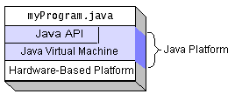
Fig 3.3 java plat form
Native code is code that after you compile it, the compiled code runs on a specific hardware platform. As a platform-independent environment, the Java platform can be a bit slower than native code. However, smart compilers, well-tuned interpreters, and just-in-time byte code compilers can bring performance close to that of native code without threatening portability.

What Can Java Technology Do?
The most common types of programs written in the Java programming language are applets and applications. If you’ve surfed the Web, you’re probably already familiar with applets. An applet is a program that adheres to certain conventions that allow it to run within a Java-enabled browser.
However, the Java programming language is not just for writing cute, entertaining applets for the Web. The general-purpose, high-level Java programming language is also a powerful software platform. Using the generous API, you can write many types of programs.
An application is a standalone program that runs directly on the Java platform. A special kind of application known as a server serves and supports clients on a network. Examples of servers are Web servers, proxy servers, mail servers, and print servers. Another specialized program is a servlet. A servlet can almost be thought of as an applet that runs on the server side. Java Servlets are a popular choice for building interactive web applications, replacing the use of CGI scripts. Servlets are similar to applets in that they are runtime extensions of applications. Instead of working in browsers, though, servlets run within Java Web servers, configuring or tailoring the server.
How does the API support all these kinds of programs? It does so with packages of software components that provides a wide range of functionality. Every full implementation of the Java platform gives you the following features:
- The essentials: Objects, strings, threads, numbers, input and output, data structures, system properties, date and time, and so on.
- Applets: The set of conventions used by applets.
- Networking: URLs, TCP (Transmission Control Protocol), UDP (User Data gram Protocol) sockets, and IP (Internet Protocol) addresses.
- Internationalization: Help for writing programs that can be localized for users worldwide. Programs can automatically adapt to specific locales and be displayed in the appropriate language.
- Security: Both low level and high level, including electronic signatures, public and private key management, access control, and certificates.
- Software components: Known as JavaBeansTM, can plug into existing component architectures.
- Object serialization: Allows lightweight persistence and communication via Remote Method Invocation (RMI).
- Java Database Connectivity (JDBCTM): Provides uniform access to a wide range of relational databases.
The Java platform also has APIs for 2D and 3D graphics, accessibility, servers, collaboration, telephony, speech, animation, and more. The following figure depicts what is included in the Java 2 SDK.

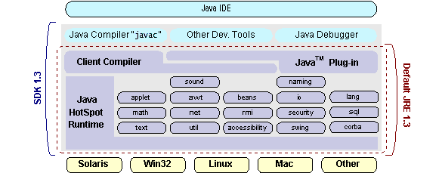

Fig 3.4 java ide

How Will Java Technology Change My Life?
We can’t promise you fame, fortune, or even a job if you learn the Java programming language. Still, it is likely to make your programs better and requires less effort than other languages. We believe that Java technology will help you do the following:
- Get started quickly: Although the Java programming language is a powerful object-oriented language, it’s easy to learn, especially for programmers already familiar with C or C++.
- Write less code: Comparisons of program metrics (class counts, method counts, and so on) suggest that a program written in the Java programming language can be four times smaller than the same program in C++.
- Write better code: The Java programming language encourages good coding practices, and its garbage collection helps you avoid memory leaks. Its object orientation, its JavaBeans component architecture, and its wide-ranging, easily extendible API let you reuse other people’s tested code and introduce fewer bugs.
- Develop programs more quickly: Your development time may be as much as twice as fast versus writing the same program in C++. Why? You write fewer lines of code and it is a simpler programming language than C++.
- Avoid platform dependencies with 100% Pure Java: You can keep your program portable by avoiding the use of libraries written in other languages. The 100% Pure JavaTMProduct Certification Program has a repository of historical process manuals, white papers, brochures, and similar materials online.
- Write once, run anywhere: Because 100% Pure Java programs are compiled into machine-independent byte codes, they run consistently on any Java platform.
- Distribute software more easily: You can upgrade applets easily from a central server. Applets take advantage of the feature of allowing new classes to be loaded “on the fly,” without recompiling the entire program.

ODBC
Microsoft Open Database Connectivity (ODBC) is a standard programming interface for application developers and database systems providers. Before ODBC became a de facto standard for Windows programs to interface with database systems, programmers had to use proprietary languages for each database they wanted to connect to. Now, ODBC has made the choice of the database system almost irrelevant from a coding perspective, which is as it should be. Application developers have much more important things to worry about than the syntax that is needed to port their program from one database to another when business needs suddenly change.
Through the ODBC Administrator in Control Panel, you can specify the particular database that is associated with a data source that an ODBC application program is written to use. Think of an ODBC data source as a door with a name on it. Each door will lead you to a particular database. For example, the data source named Sales Figures might be a SQL Server database, whereas the Accounts Payable data source could refer to an Access database. The physical database referred to by a data source can reside anywhere on the LAN.
The ODBC system files are not installed on your system by Windows 95. Rather, they are installed when you setup a separate database application, such as SQL Server Client or Visual Basic 4.0. When the ODBC icon is installed in Control Panel, it uses a file called ODBCINST.DLL. It is also possible to administer your ODBC data sources through a stand-alone program called ODBCADM.EXE. There is a 16-bit and a 32-bit version of this program and each maintains a separate list of ODBC datasources.
From a programming perspective, the beauty of ODBC is that the application can be written to use the same set of function calls to interface with any data source, regardless of the database vendor. The source code of the application doesn’t change whether it talks to Oracle or SQL Server. We only mention these two as an example. There are ODBC drivers available for several dozen popular database systems. Even Excel spreadsheets and plain text files can be turned into data sources. The operating system uses the Registry information written by ODBC Administrator to determine which low-level ODBC drivers are needed to talk to the data source (such as the interface to Oracle or SQL Server). The loading of the ODBC drivers is transparent to the ODBC application program. In a client/server environment, the ODBC API even handles many of the network issues for the application programmer.
The advantages of this scheme are so numerous that you are probably thinking there must be some catch. The only disadvantage of ODBC is that it isn’t as efficient as talking directly to the native database interface. ODBC has had many detractors make the charge that it is too slow. Microsoft has always claimed that the critical factor in performance is the quality of the driver software that is used. In our humble opinion, this is true. The availability of good ODBC drivers has improved a great deal recently. And anyway, the criticism about performance is somewhat analogous to those who said that compilers would never match the speed of pure assembly language. Maybe not, but the compiler (or ODBC) gives you the opportunity to write cleaner programs, which means you finish sooner. Meanwhile, computers get faster every year.

JDBC
In an effort to set an independent database standard API for Java; Sun Microsystems developed Java Database Connectivity, or JDBC. JDBC offers a generic SQL database access mechanism that provides a consistent interface to a variety of RDBMSs. This consistent interface is achieved through the use of “plug-in” database connectivity modules, or drivers. If a database vendor wishes to have JDBC support, he or she must provide the driver for each platform that the database and Java run on.
To gain a wider acceptance of JDBC, Sun based JDBC’s framework on ODBC. As you discovered earlier in this chapter, ODBC has widespread support on a variety of platforms. Basing JDBC on ODBC will allow vendors to bring JDBC drivers to market much faster than developing a completely new connectivity solution.
JDBC was announced in March of 1996. It was released for a 90 day public review that ended June 8, 1996. Because of user input, the final JDBC v1.0 specification was released soon after.
The remainder of this section will cover enough information about JDBC for you to know what it is about and how to use it effectively. This is by no means a complete overview of JDBC. That would fill an entire book.

JDBC Goals
Few software packages are designed without goals in mind. JDBC is one that, because of its many goals, drove the development of the API. These goals, in conjunction with early reviewer feedback, have finalized the JDBC class library into a solid framework for building database applications in Java.
The goals that were set for JDBC are important. They will give you some insight as to why certain classes and functionalities behave the way they do. The eight design goals for JDBC are as follows:
- SQL Level API
The designers felt that their main goal was to define a SQL interface for Java. Although not the lowest database interface level possible, it is at a low enough level for higher-level tools and APIs to be created. Conversely, it is at a high enough level for application programmers to use it confidently. Attaining this goal allows for future tool vendors to “generate” JDBC code and to hide many of JDBC’s complexities from the end user.
- SQL Conformance
SQL syntax varies as you move from database vendor to database vendor. In an effort to support a wide variety of vendors, JDBC will allow any query statement to be passed through it to the underlying database driver. This allows the connectivity module to handle non-standard functionality in a manner that is suitable for its users.
- JDBC must be implemental on top of common database interfaces
The JDBC SQL API must “sit” on top of other common SQL level APIs. This goal allows JDBC to use existing ODBC level drivers by the use of a software interface. This interface would translate JDBC calls to ODBC and vice versa.
- Provide a Java interface that is consistent with the rest of the Java system
Because of Java’s acceptance in the user community thus far, the designers feel that they should not stray from the current design of the core Java system.
- Keep it simple
This goal probably appears in all software design goal listings. JDBC is no exception. Sun felt that the design of JDBC should be very simple, allowing for only one method of completing a task per mechanism. Allowing duplicate functionality only serves to confuse the users of the API.
- Use strong, static typing wherever possible
Strong typing allows for more error checking to be done at compile time; also, less error appear at runtime.
- Keep the common cases simple
Because more often than not, the usual SQL calls used by the programmer are simple SELECT’s, INSERT’s, DELETE’s and UPDATE’s, these queries should be simple to perform with JDBC. However, more complex SQL statements should also be possible.
Finally we decided to proceed the implementation using Java Networking.
And for dynamically updating the cache table we go for MS Access database.

Java ha two things: a programming language and a platform.

Java is a high-level programming language that is all of the following

Simple Architecture-neutral

Object-oriented Portable

Distributed High-performance

Interpreted multithreaded

Robust Dynamic

Secure

Java is also unusual in that each Java program is both compiled and interpreted. With a compile you translate a Java program into an intermediate language called Java byte codes the platform-independent code instruction is passed and run on the computer.

Compilation happens just once; interpretation occurs each time the program is executed. The figure illustrates how this works.
JavaProgram
Compilers
Interpreter
My Program

Fig 3.5 java compiler

You can think of Java byte codes as the machine code instructions for the Java Virtual Machine (Java VM). Every Java interpreter, whether it’s a Java development tool or a Web browser that can run Java applets, is an implementation of the Java VM. The Java VM can also be implemented in hardware.

Java byte codes help make “write once, run anywhere” possible. You can compile your Java program into byte codes on my platform that has a Java compiler. The byte codes can then be run any implementation of the Java VM. For example, the same Java program can run Windows NT, Solaris, and Macintosh.

NetworkingTCP/IP stack
The TCP/IP stack is shorter than the OSI one:
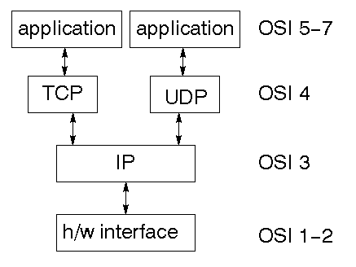
Fig 3.6 networking TCP/IP
TCP is a connection-oriented protocol; UDP (User Datagram Protocol) is a connectionless protocol.

IP datagram’s
The IP layer provides a connectionless and unreliable delivery system. It considers each datagram independently of the others. Any association between datagram must be supplied by the higher layers. The IP layer supplies a checksum that includes its own header. The header includes the source and destination addresses. The IP layer handles routing through an Internet. It is also responsible for breaking up large datagram into smaller ones for transmission and reassembling them at the other end.

UDP
UDP is also connectionless and unreliable. What it adds to IP is a checksum for the contents of the datagram and port numbers. These are used to give a client/server model - see later.

TCP
TCP supplies logic to give a reliable connection-oriented protocol above IP. It provides a virtual circuit that two processes can use to communicate.

Internet addresses
In order to use a service, you must be able to find it. The Internet uses an address scheme for machines so that they can be located. The address is a 32 bit integer which gives the IP address. This encodes a network ID and more addressing. The network ID falls into various classes according to the size of the network address.

Network address
Class A uses 8 bits for the network address with 24 bits left over for other addressing. Class B uses 16 bit network addressing. Class C uses 24 bit network addressing and class D uses all 32.

Subnet address
Internally, the UNIX network is divided into sub networks. Building 11 is currently on one sub network and uses 10-bit addressing, allowing 1024 different hosts.

Host address
8 bits are finally used for host addresses within our subnet. This places a limit of 256 machines that can be on the subnet.

Total address
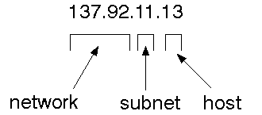
Fig 3.7 total address
The 32 bit address is usually written as 4 integers separated by dots.

Port addresses
A service exists on a host, and is identified by its port. This is a 16 bit number. To send a message to a server, you send it to the port for that service of the host that it is running on. This is not location transparency! Certain of these ports are "well known".

Sockets
A socket is a data structure maintained by the system to handle network connections. A socket is created using the call socket. It returns an integer that is like a file descriptor. In fact, under Windows, this handle can be used with Read File and Write File functions.
#include <sys/types.h>
#include <sys/socket.h>
int socket(int family, int type, int protocol);
Here "family" will be AF_INET for IP communications, protocol will be zero, and type will depend on whether TCP or UDP is used. Two processes wishing to communicate over a network create a socket each. These are similar to two ends of a pipe - but the actual pipe does not yet exist.
JFree Chart
JFreeChart is a free 100% Java chart library that makes it easy for developers to display professional quality charts in their applications. JFreeChart's extensive feature set includes:
A consistent and well-documented API, supporting a wide range of chart types;
A flexible design that is easy to extend, and targets both server-side and client-side applications;
Support for many output types, including Swing components, image files (including PNG and JPEG), and vector graphics file formats (including PDF, EPS and SVG);
JFreeChart is "open source" or, more specifically, free software. It is distributed under the terms of the GNU Lesser General Public Licence (LGPL), which permits use in proprietary applications.

1. Map Visualizations
Charts showing values that relate to geographical areas. Some examples include: (a) population density in each state of the United States, (b) income per capita for each country in Europe, (c) life expectancy in each country of the world. The tasks in this project include:
Sourcing freely redistributable vector outlines for the countries of the world, states/provinces in particular countries (USA in particular, but also other areas);
Creating an appropriate dataset interface (plus default implementation), a rendered, and integrating this with the existing XYPlot class in JFreeChart;
Testing, documenting, testing some more, documenting some more.

2. Time Series Chart Interactivity

Implement a new (to JFreeChart) feature for interactive time series charts --- to display a separate control that shows a small version of ALL the time series data, with a sliding "view" rectangle that allows you to select the subset of the time series data to display in the main chart.

3. Dashboards

There is currently a lot of interest in dashboard displays. Create a flexible dashboard mechanism that supports a subset of JFreeChart chart types (dials, pies, thermometers, bars, and lines/time series) that can be delivered easily via both Java Web Start and an applet.

4. Property Editors

The property editor mechanism in JFreeChart only handles a small subset of the properties that can be set for charts. Extend (or reimplement) this mechanism to provide greater end-user control over the appearance of the charts.

Tomcat 6.0 web server
Tomcat is an open source web server developed by Apache Group. Apache Tomcat is the servlet container that is used in the official Reference Implementation for the Java Servlet and JavaServer Pages technologies. The Java Servlet and JavaServer Pages specifications are developed by Sun under the Java Community Process. Web Servers like Apache Tomcat support only web components while an application server supports web components as well as business components (BEAs Weblogic, is one of the popular application server).To develop a web application with jsp/servlet install any web server like JRun, Tomcat etc to run your application.
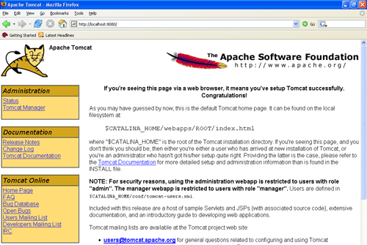

Fig 3.8 Tomcat Webserver

CHAPTER IV

DESIGN AND DEVELOPMENT
4.1 INTRODUCTION
The most creative and challenging phase of the life cycle is system and design. The term design describes a final system and the process by which it is developed. It refer to the technical specifications that will be applied in implementation the candidate system. The design may be defined as “the process of applying various techniques and principles for the purpose of defining a device, a process or a system in sufficient details to permit its physical realization”.
The design’s goal is how the output is to be produced and in what format samples of the output and input are also presented. Second input data and database files have to be designed to meet the requirements of the proposed output. The processing phase is handled through the program construction and testing. Finally details related to justification of the system and an estimate of the impact of the candidate system on the users and the organization are documented and evaluated by management as a step toward implementation.
The importance of software design can be stated in a single word “Quality”. Design provides us with representation of software that can be assessed for quality. Design is the only way that we can accurately translate a customer’s requirements into a finished software product or system without design we risk building an unstable system, that might fail it small changes are made or may be difficult to test, or one who’s quality can’t be tested. So it is an essential phase in the development of a software product.
4.2 SPIRAL MODEL
SDLC METHODOLOGY
The document ply vital role in the development of life cycle (SDLC) as it describes the complete requirement of the system. It means for use by developers and will be the basic during testing phase. Any changes made to the requirements in the future will have to go through formal change approval process.
SPIRAL MODEL was defined by Barry Boehm in his 1988 article, “A spiral model of Software Development and Enhancement.
.
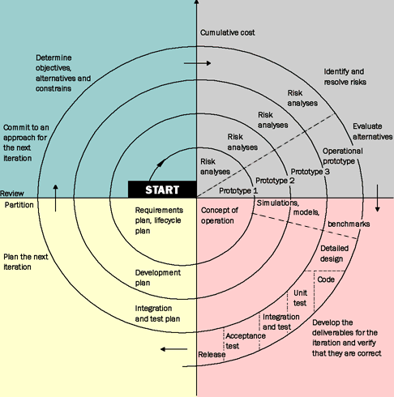
FIG :4.1 SDLC METHODOLOGY
Advantages of Spiral model:
- High amount of risk analysis hence, avoidance of Risk is enhanced.
- Good for large and mission-critical projects.
- Strong approval and documentation control.
- Additional Functionality can be added at a later date.
- Software is produced early in the software life cycle.

Disadvantages of Spiral model:
- Can be a costly model to use.
- Risk analysis requires highly specific expertise.
- Project’s success is highly dependent on the risk analysis phase.
- Doesn’t work well for smaller projects.
When to use Spiral model:
- When costs and risk evaluation is important
- For medium to high-risk projects
- Long-term project commitment unwise because of potential changes to economic priorities
- Requirements are complex
- New product line.
- Significant changes are expected (research and exploration).
4.3 DATABASE AND TABLES:
A database management system (DBMS) is computer software designed for the purpose of managing databases, a large set of structured data, and run operations on the data requested by numerous users. Typical examples of DBMSs include Oracle, DB2, Microsoft Access, Microsoft SQL Server, Firebird, PostgreSQL, MySQL, SQLite, FileMaker and Sybase Adaptive Server Enterprise. DBMSs are typically used by Database administrators in the creation of Database systems. Typical examples of DBMS use include accounting, human resources and customer support systems.
Originally found only in large companies with the computer hardware needed to support large data sets, DBMSs have more recently emerged as a fairly standard part of any company back office.
Description:
A DBMS is a complex set of software programs that controls the organization, storage, management, and retrieval of data in a database. A DBMS includes:
- A modeling language to define the schema of each database hosted in the DBMS, according to the DBMS data model.
- The four most common types of organizations are the hierarchical, network, relational and object models. Inverted lists and other methods are also used. A given database management system may provide one or more of the four models. The optimal structure depends on the natural organization of the application's data, and on the application's requirements (which include transaction rate (speed), reliability, maintainability, scalability, and cost).
- The dominant model in use today is the ad hoc one embedded in SQL, despite the objections of purists who believe this model is a corruption of the relational model, since it violates several of its fundamental principles for the sake of practicality and performance. Many DBMSs also support the Open Database Connectivity API that supports a standard way for programmers to access the DBMS.
- Data structures (fields, records, files and objects) optimized to deal with very large amounts of data stored on a permanent data storage device (which implies relatively slow access compared to volatile main memory).
- A database query language and report writer to allow users to interactively interrogate the database, analyze its data and update it according to the users privileges on data.
- It also controls the security of the database.
- Data security prevents unauthorized users from viewing or updating the database. Using passwords, users are allowed access to the entire database or subsets of it called subschemas. For example, an employee database can contain all the data about an individual employee, but one group of users may be authorized to view only payroll data, while others are allowed access to only work history and medical data.
- If the DBMS provides a way to interactively enter and update the database, as well as interrogate it, this capability allows for managing personal databases. However, it may not leave an audit trail of actions or provide the kinds of controls necessary in a multi-user organization. These controls are only available when a set of application programs are customized for each data entry and updating function.
- A transaction mechanism, that ideally would guarantee the ACID properties, in order to ensure data integrity, despite concurrent user accesses (concurrency control), and faults (fault tolerance).
- It also maintains the integrity of the data in the database.
- The DBMS can maintain the integrity of the database by not allowing more than one user to update the same record at the same time. The DBMS can help prevent duplicate records via unique index constraints; for example, no two customers with the same customer numbers (key fields) can be entered into the database. See ACID properties for more information (Redundancy avoidance).
The DBMS accepts requests for data from the application program and instructs the operating system to transfer the appropriate data.
When a DBMS is used, information systems can be changed much more easily as the organization's information requirements change. New categories of data can be added to the database without disruption to the existing system.
Organizations may use one kind of DBMS for daily transaction processing and then move the detail onto another computer that uses another DBMS better suited for random inquiries and analysis. Overall systems design decisions are performed by data administrators and systems analysts. Detailed database design is performed by database administrators.
Database servers are specially designed computers that hold the actual databases and run only the DBMS and related software. Database servers are usually multiprocessor computers, with RAID disk arrays used for stable storage. Connected to one or more servers via a high-speed channel, hardware database accelerators are also used in large volume transaction processing environments.
DBMSs are found at the heart of most database applications. Sometimes DBMSs are built around a private multitasking kernel with built-in networking support although nowadays these functions.
SQL
Structured Query Language (SQL) is the language used to manipulate relational databases. SQL is tied very closely with the relational model.
In the relational model, data is stored in structures called relations or tables.
SQL statements are issued for the purpose of:
Data definition: Defining tables and structures in the database (DDL used to create, alter and drop schema objects such as tables and indexes).
Data manipulation: Used to manipulate the data within those schema objects (DML Inserting, Updating, Deleting the data, and Querying the Database).
A schema is a collection of database objects that can include: tables, views, indexes and sequences
List of SQL statements that can be issued against an Oracle database schema are:
- ALTER - Change an existing table, view or index definition (DDL)
- AUDIT - Track the changes made to a table (DDL)
- COMMENT - Add a comment to a table or column in a table (DDL)
- COMMIT - Make all recent changes permanent (DML - transactional)
- CREATE - Create new database objects such as tables or views (DDL)
- DELETE- Delete rows from a database table (DML)
- DROP - Drop a database object such as a table, view or index (DDL)
- GRANT - Allow another user to access database objects such as tables or views (DDL)
- INSERT - Insert new data into a database table (DML)
- No AUDIT - Turn off the auditing function (DDL)
- REVOKE - Disallow a user access to database objects such as tables and views (DDL)
- ROLLBACK - Undo any recent changes to the database (DML - Transactional)
- SELECT - Retrieve data from a database table (DML)
- TRUNCATE - Delete all rows from a database table (can not be rolled back) (DML)
- UPDATE- Change the values of some data items in a database table (DML)

4.3 DFD/ER/UML DIAGRAM
The overall logical structure of a database can be expressed graphically by an E-R diagram. The relative simplicity and pictorial clarity of this diagramming technique may well account in large part for the widespread use of the E-R model. Such a diagram consists of the following major components.
Rectangles: Represent Entity Sets.
Ellipses: Represent attributes.
Diamonds: Represent relationship sets
Lines: Link attributes to entity sets and entity sets
4.4 DATA MODELING
DFD DIAGRAM
- The DFD is also called as bubble chart. It is a simple graphical formalism that can be used to represent a system in terms of input data to the system, various processing carried out on this data, and the output data is generated by this system.
- The data flow diagram (DFD) is one of the most important modeling tools. It is used to model the system components. These components are the system process, the data used by the process, an external entity that interacts with the system and the information flows in the system.
- DFD shows how the information moves through the system and how it is modified by a series of transformations. It is a graphical technique that depicts information flow and the transformations that are applied as data moves from input to output.
- DFD is also known as bubble chart. A DFD may be used to represent a system at any level of abstraction. DFD may be partitioned into levels that represent increasing information flow and functional detail.
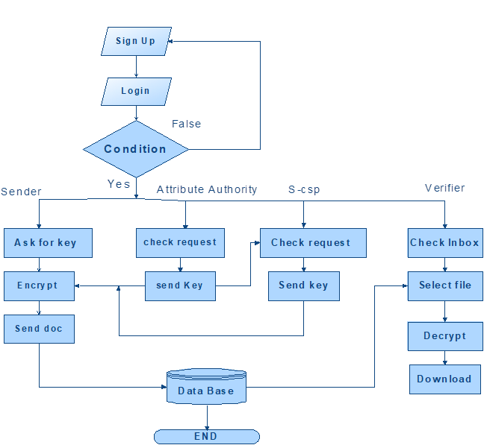
Fig:4.1DFD diagram
UML DIAGRAMS
Introduction to UML
UML is a method for describing the system architecture in detail using the blue print. UML implies a gathering of best building watches that have affirmed effective in the displaying of enormous and troublesome frameworks. The UML is an exceptionally noteworthy piece of creating articles situated programming and the product improvement process. The UML utilizes for the most part graphical documentations to positive the outline of programming tasks. Spending the UML tasks groups interconnect, find potential plans, and approve the structural configuration of the product.
Definition: UML is a general purpose visual modeling language that is used to specify,visualize, construct, and document the artifacts of the software system.
UML is a language: It will provide vocabulary and rules for communications and function on conceptual and physical representation. So it is modeling language.
UML Specifying: Specifying means building models that are precise, unambiguous and complete. In particular, the UML address the specification of all the important analysis, design and implementation decisions that must be made in developing and displaying a software intensive system.
UML Visualization: The UML includes both graphical and textual representation. It makes easy to visualize the system and for better understanding.
UML Constructing: UML models can be directly connected to a variety of programming languages and it is sufficiently expressive and free from any ambiguity to permit the direct execution of models.
UML Documenting: UML provides variety of documents in addition raw executable codes.
Uses of UML:
The UML is intended primarily for software intensive systems. It has been used effectively for such domain as
1 .Enterprise Information System
- Banking and Financial Services
- Telecommunications
- Transportation
- Defense/Aerospace
- Retails
- Medical Electronics
- Scientific Fields
- Distributed Web
Rules of UML:
The UML has semantic rules for
- SCOPE: The content that gives specific meaning to a name.

- NAMES: It will call things, relationships and diagrams

- VISIBILITY: How those names can be seen and used by others.

- INTEGRITY: How things properly and consistently relate to another.

- EXECUTION: What it means is to run or simulate a dynamic model.

Building blocks of UML:
The vocabulary of the UML encompasses 3 kinds of building blocks
- Things

- Relationships

- Diagrams

Things:
Things are the data abstractions that are first class citizens in a model. Things are of 4 types
- Structural Things

- Behavioral Things

- Grouping Things

- An notational Things
Relationships:
Relationships tie the things together. Relationships in the UML are
- Dependency

- Association

- Generalization Specialization

UML Diagrams:
Diagrams in the UML are of 2 types
- Static or Structural Diagrams

- Dynamic or Behavioral Diagrams
Static:
- Class diagrams

- Object diagrams.

- Component diagrams.

- Deployment diagrams
Dynamic:
- Use Case diagram.

- Sequence diagram

- Collaboration diagram.

- State Chart diagram.

- Activity diagram.

CLASS DIAGRAM:
In software engineering, a class diagram in the Unified Modeling Language (UML) is a type of static structure diagram that describes the structure of a system by showing the system's classes, their attributes, operations (or methods), and the relationships among the classes. It explains which class contains information.
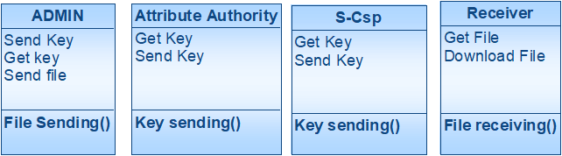
Fig. 4.2 Class Diagram
USE CASE DIAGRAM:
A use case diagram in the Unified Modeling Language (UML is a kind of behavioral outline positive by and produced using a Use-contextual investigation. Its determination is to surviving a graphical sign of the usefulness giving by a framework regarding performing artists and their points (spoke to as use cases), and any conditions between those utilization cases. The key reason for an utilization case outline is to show what framework capacities are performed for which on-screen character. Parts of the on-screen characters in the framework can be delineated.

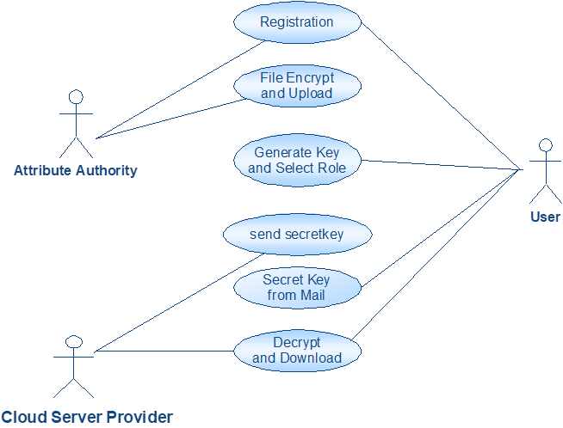
Fig.4.3 Use case Diagram

Sequence Diagram
A sequence diagram in Unified Modeling Language (UML) is a kind of interaction diagram that shows how processes operate with one another and in what order. It is a construct of a Message Sequence Chart. Sequence diagrams are sometimes called event diagrams, event scenarios, and timing diagrams.

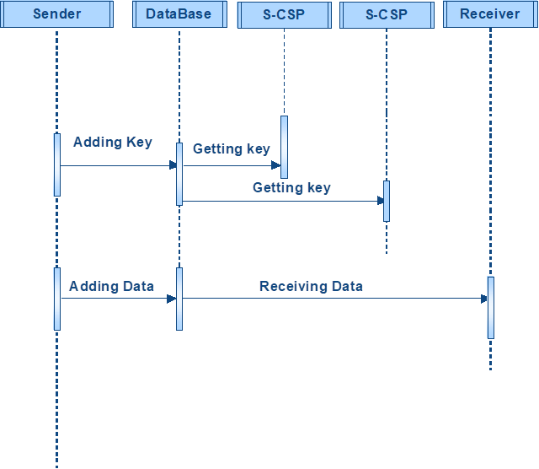
fig 4.4 sequence diagram
Activity Diagram:
Activity diagrams are graphical representations of workflows of stepwise activities and actions with support for choice, iteration and concurrency. In the Unified Modeling Language, activity diagrams can be used to describe the business and operational step-by-step workflows of components in a system. An activity diagram shows the overall flow of control.
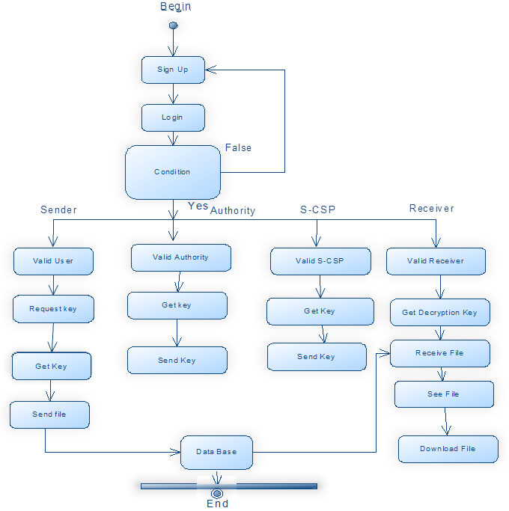

Fig 4.5 activity diagram
4.5MODULES
Implementation is the stage of the project when the theoretical design is turned out into a working system. Thus it can be considered to be the most critical stage in achieving a successful new system and in giving the user, confidence that the new system will work and be effective.
The implementation stage involves careful planning, investigation of the existing system and it’s constraints on implementation, designing of methods to achieve changeover and evaluation of changeover methods.
- Cloud server
- Group of users
- Public verifier
- Auditing Module
MODULE DESCRIPTION:
Cloud server
- In the first module, we design our system with Cloud Server, where the datas are stored globally. Our mechanism, Oruta, should be designed to achieve following properties:
- (1) Public Auditing: A public verifier is able to publicly verify the integrity of shared data without retrieving the entire data from the cloud.
- (2) Correctness: A public verifier is able to correctly verify shared data integrity.
- (3) Unforgeability: Only a user in the group can generate valid verification metadata (i.e., signatures) on shared data.
- (4) Identity Privacy: A public verifier cannot distinguish the identity of the signer on each block in shared data during the process of auditing.
Group of users
- There are two types of users in a group: the original user and a number of group users. The original user initially creates shared data in the cloud, and shares it with group users. Both the original user and group users are members of the group. Every member of the group is allowed to access and modify shared data. Shared data and its verification metadata (i.e., signatures) are both stored in the cloud server. A public verifier, such as a third party auditor providing expert data auditing services or a data user outside the group intending to utilize shared data, is able to publicly verify the integrity of shared data stored in the cloud server.
- Owner Registration: In this module an owner has to upload its files in a cloud server, he/she should register first. Then only he/she can be able to do it. For that he needs to fill the details in the registration form. These details are maintained in a database.
- Owner Login: In this module, owners have to login, they should login by giving their email id and password.
- User Registration: In this module if a user wants to access the data which is stored in a cloud, he/she should register their details first. These details are maintained in a Database.
- User Login: If the user is an authorized user, he/she can download the file by using file id which has been stored by data owner when it was uploading.
Public verifier
- When a public verifier wishes to check the integrity of shared data, it first sends an auditing challenge to the cloud server. After receiving the auditing challenge, the Cloud server responds to the public verifier with an auditing proof of the possession of shared data.
- Then, this public verifier checks the correctness of the entire data by verifying the correctness of the auditing proof. Essentially, the process of public auditing is a challenge and- response protocol between a public verifier and the cloud server
Auditing Module
- In this module, if a third party auditor TPA (maintainer of clouds) should register first. This system allows only cloud service providers. After third party auditor gets logged in, He/ She can see how many data owners have uploaded their files into the cloud. Here we are providing TPA for maintaining clouds.
- We only consider how to audit the integrity of shared data in the cloud with static groups. It means the group is pre-defined before shared data is created in the cloud and the membership of users in the group is not changed during data sharing.
- The original user is responsible for deciding who is able to share her data before outsourcing data to the cloud. Another interesting problem is how to audit the integrity of shared data in the cloud with dynamic groups — a new user can be added into the group and an existing group member can be revoked during data sharing — while still preserving identity privacy.

CHAPTER V

TESTING AND VALIDATION
The goal of testing is to acquire errors. Testing is that the technique of trying to get each possible error or weakness in an extremely work product. It provides the way to observe the practicality of parts, sub-assemblies, assemblies and or a finished product it is the technique of effort code with the concentrating of guaranteeing that the software meets its requirements and user hopes and does not fail in an undesirable manner. There are numerous sorts of check. Every check sort reports a designated testing demand.
Testing objectives:
The key objective of testing is to determine a mass of errors, systematically and with minimum effort and time. Stating formally, we can say, testing is a process of executing a program with resolved of discover an error.
- A successful test is one that determines an as however undiscovered error.
- A good test case is one that has possibility of discover an error, if it exists.
- The test is insufficient to detect possibly present errors.
- The software more or less approves to the quality and unswerving standards.

5.1 Types of Testing
The basic levels of Testing:
Client needs acceptance testing

equirements system testing

Design integration testing

Code unit testing

Fig. 5.1 Levels of Testing

Functional Testing
Real tests give efficient protests that functions tested are attainable as specific by the business and technical requirements, system documentation, and user manuals.
Functional testing is focused on the subsequent items:
Valid Input : known categories of valid input should be accepted.
Invalid Input : known categories of invalid input should be rejected.
5.2 TYPES OF TESTS
Unit testing:
A unit is the smallest piece of source code that can be tested. It is also known as a module which consists of numerous lines of code that are processed by a single programmer. The key purpose of performing unit testing is to expose that a particular unit doesn’t satisfy the specified functional requirements and also to show that the structural implementation is not like to the projected structure designed.
Integration testing:
Integration tests are intended to test incorporated programming segments to figure out whether they really keep running as one system. Testing is occasion driven and is more worried with the fundamental result of screens or fields. Reconciliation tests exhibit that in spite of the fact that the parts were separately fulfillment, as appeared by effectively unit testing, the blend of segments is right and comprised. Integration testing is specifically aimed at revealing the problems that rise from the mixture of components.
Functional test
Functional tests give efficient challenges that capacities tried are accessible as determined by the business and specialized necessities, framework documentation, and client manuals Functional testing is centered on the following items:
Valid Input: identified classes of valid input must be accepted.
Invalid Input: identified classes of invalid input must be rejected.
Functions: identified functions must be exercised.
Output : identified classes of application outputs must be exercised.
Systems/Procedures: interfacing systems or procedures must be invoked.
Association and arrangement of practical tests is centered around prerequisites, key capacities, or unique experiments. Likewise, efficient scope relating to recognize Business procedure streams; information fields, predefined procedures, and progressive procedures must be considered for testing. Before utilitarian testing is finished, extra tests are distinguished and the powerful estimation of current tests is resolved.
System Test
System testing guarantees that the entire coordinated programming framework meets prerequisites. It tests a design to guarantee known and unsurprising results. A sample of framework testing is the arrangement situated framework combination test. Framework testing depends on procedure portrayals and streams, stressing pre-driven procedure connections and mix focuses.
White Box Testing
It is a testing in which the product analyzer has information of the internal workings, structure and dialect of the product, or if nothing else its motivation. It is reason. It is utilized to test ranges that can't be gotten a handle on from a discovery level.
Black Box Testing
It is the testing the product with no information of within workings, structure or dialect of the part being tried. Discovery tests, as most different sorts of tests, must be composed from a complete source report, for example, prerequisite or necessities archive, for example, determination or necessities record. It is a trying in which the product under test is dealt with, as a discovery .you can't "see" into it. The test gives inputs and reacts to yields without considering how the product functions.
Unit Testing:
Unit testing is by and large appeared as a major aspect of a joined code and unit test period of the product lifecycle, in spite of the fact that it is not exceptional for coding and unit testing to be directed as two unmistakable stages.

Test strategy and approach
Ground testing will be done physically and functional tests will be inscribed in detail.
Test objectives
- All field admissions essentially work appropriately.
- Pages must be activated from the identified link.
- The entry screen, messages and responses must not be delayed.
Features to be tested
- Validate that the accesses are of the correct format
- No duplicate entries should be allowed
- Entire links must gross the user to the accurate page.
Integration Testing
Software integration testing is the incremental combination analysis of two or more joint software components on a single platform to generate failures created by boundary faults.
The task of the integration test is to design those components or s/w applications, e.g. modules in a software system or – one step up – software presentations at the company level
– interact without faults.
Test Results: All the test cases stated above passed effectively. No defects met.
Acceptance Testing
User Acceptance Testing is a serious phase of any project and needs important contribution by the end user. It also guarantees that the system encounters the functional requirements.
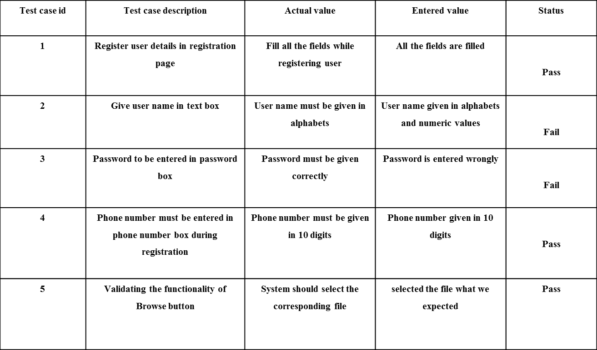

Fig 5.10: Testcase Template

Test Results: All the test cases stated above passed effectively. No defects met.

#!/usr/bin/env python3
"""
NaptProxy - A Python-based proxy server for intercepting and analyzing vulnerability scanner traffic
"""
import os
import sys
import logging
import threading
import argparse
from proxy_server import ProxyServer
from web_interface import app, start_web_interface, set_proxy_server

# Set up logging
logging.basicConfig(
level=logging.INFO,
format='%(asctime)s - %(name)s - %(levelname)s - %(message)s',
handlers=[
logging.FileHandler("naptyproxy.log"),
logging.StreamHandler(sys.stdout)
]
)
logger = logging.getLogger("NaptProxy")

def parse_arguments():
"""Parse command line arguments"""
parser = argparse.ArgumentParser(description='NaptProxy - A vulnerability scanner traffic proxy server')

# Proxy configuration
parser.add_argument('--proxy-host', type=str, default='0.0.0.0',
help='Host for the proxy server (default: 0.0.0.0)')
parser.add_argument('--proxy-port', type=int, default=8000,
help='Port for the proxy server (default: 8000)')

# Web interface configuration
parser.add_argument('--web-host', type=str, default='0.0.0.0',
help='Host for the web interface (default: 0.0.0.0)')
parser.add_argument('--web-port', type=int, default=5000,
help='Port for the web interface (default: 5000)')

# Logging configuration
parser.add_argument('--log-level', type=str, choices=['DEBUG', 'INFO', 'WARNING', 'ERROR', 'CRITICAL'],
default='INFO', help='Set the logging level (default: INFO)')
parser.add_argument('--log-file', type=str, default='naptyproxy.log',
help='File to save logs (default: naptyproxy.log)')

# SSL interception
parser.add_argument('--intercept-ssl', action='store_true',
help='Enable SSL/TLS interception (requires CA certificate)')
parser.add_argument('--ca-cert', type=str, default='ca/ca.crt',
help='Path to CA certificate (default: ca/ca.crt)')
parser.add_argument('--ca-key', type=str, default='ca/ca.key',
help='Path to CA private key (default: ca/ca.key)')

# Advanced options
parser.add_argument('--buffer-size', type=int, default=8192,
help='Socket buffer size in bytes (default: 8192)')
parser.add_argument('--timeout', type=int, default=60,
help='Socket timeout in seconds (default: 60)')
parser.add_argument('--max-connections', type=int, default=100,
help='Maximum number of concurrent connections (default: 100)')

return parser.parse_args()

# Create and configure proxy server with default settings
# This instance will be used when running with Gunicorn
default_proxy = ProxyServer(
host='0.0.0.0',
port=8000,
buffer_size=8192,
timeout=60,
max_connections=100,
intercept_ssl=False,
ca_cert='ca/ca.crt',
ca_key='ca/ca.key'
)

# Start the proxy server in a thread
proxy_thread = threading.Thread(target=default_proxy.start)
proxy_thread.daemon = True
proxy_thread.start()

# Set the proxy server instance in the Flask app and get the configured app
app = set_proxy_server(default_proxy)

if __name__ == "__main__":
args = parse_arguments()

# Set log level based on arguments
log_level = getattr(logging, args.log_level)
logging.basicConfig(level=log_level)

# Create and configure proxy server with command line arguments
proxy_server = ProxyServer(
host=args.proxy_host,
port=args.proxy_port,
buffer_size=args.buffer_size,
timeout=args.timeout,
max_connections=args.max_connections,
intercept_ssl=args.intercept_ssl,
ca_cert=args.ca_cert,
ca_key=args.ca_key
)

# Start proxy server in a separate thread
proxy_thread = threading.Thread(target=proxy_server.start)
proxy_thread.daemon = True
proxy_thread.start()

logger.info(f"Proxy server started on {args.proxy_host}:{args.proxy_port}")

# Start web interface (this will block)
start_web_interface(args.web_host, args.web_port, proxy_server)

% extends 'layout.html' %}

{% block title %}Dashboard{% endblock %}

{% block header %}Dashboard{% endblock %}

{% block header_buttons %}
<div class="btn-group me-2">
<button type="button" class="btn btn-sm btn-outline-secondary" id="refresh-dashboard">
<i data-feather="refresh-cw"></i> Refresh
</button>
</div>
{% endblock %}

{% block content %}
<div class="row">
<!-- Overview Cards -->
<div class="col-md-3 mb-4">
<div class="card bg-dark text-white h-100">
<div class="card-body">
<h5 class="card-title"><i data-feather="server" class="text-info"></i> Proxy Status</h5>
<div class="mt-3">
<div class="d-flex justify-content-between">
<span>Status</span>
<span id="status-badge" class="badge bg-success">Running</span>
</div>
<div class="d-flex justify-content-between mt-2">
<span>Uptime</span>
<span id="dashboard-uptime">0s</span>
</div>
<div class="d-flex justify-content-between mt-2">
<span>Requests/sec</span>
<span id="requests-per-second">0</span>
</div>
<div class="d-flex justify-content-between mt-2">
<span>Active Connections</span>
<span id="active-connections">0</span>
</div>
</div>
</div>
</div>
</div>

<div class="col-md-3 mb-4">
<div class="card bg-dark text-white h-100">
<div class="card-body">
<h5 class="card-title"><i data-feather="activity" class="text-info"></i> Traffic</h5>
<div class="mt-3">
<div class="d-flex justify-content-between">
<span>Total Requests</span>
<span id="dash-total-requests">0</span>
</div>
<div class="d-flex justify-content-between mt-2">
<span>Total Responses</span>
<span id="total-responses">0</span>
</div>
<div class="d-flex justify-content-between mt-2">
<span>Data In</span>
<span id="dash-total-bytes-in">0 B</span>
</div>
<div class="d-flex justify-content-between mt-2">
<span>Data Out</span>
<span id="dash-total-bytes-out">0 B</span>
</div>
</div>
</div>
</div>
</div>

<div class="col-md-3 mb-4">
<div class="card bg-dark text-white h-100">
<div class="card-body">
<h5 class="card-title"><i data-feather="shield" class="text-info"></i> Security</h5>
<div class="mt-3">
<div class="d-flex justify-content-between">
<span>SSL Interception</span>
<span id="ssl-interception" class="badge bg-secondary">Disabled</span>
</div>
<div class="d-flex justify-content-between mt-2">
<span>Total Vulnerabilities</span>
<span id="total-vulnerabilities">0</span>
</div>
<div class="d-flex justify-content-between mt-2">
<span>Scanner Signatures</span>
<span id="scanner-signatures">0</span>
</div>
</div>
</div>
</div>
</div>

<div class="col-md-3 mb-4">
<div class="card bg-dark text-white h-100">
<div class="card-body">
<h5 class="card-title"><i data-feather="settings" class="text-info"></i> Configuration</h5>
<div class="mt-3">
<div class="d-flex justify-content-between">
<span>Proxy Address</span>
<span id="dash-proxy-address">0.0.0.0:8000</span>
</div>
<div class="d-flex justify-content-between mt-2">
<span>Web Interface</span>
<span id="web-interface">0.0.0.0:5000</span>
</div>
<div class="d-flex justify-content-between mt-2">
<span>Log Level</span>
<span id="log-level">INFO</span>
</div>
</div>
<div class="mt-3">
<a href="/settings" class="btn btn-outline-info btn-sm w-100">Settings</a>
</div>
</div>
</div>
</div>
</div>

<div class="row">
<!-- Traffic Charts -->
<div class="col-md-6 mb-4">
<div class="card bg-dark text-white">
<div class="card-body">
<h5 class="card-title">Request Methods</h5>
<div class="chart-container" style="position: relative; height: 200px;">
<canvas id="request-methods-chart"></canvas>
</div>
</div>
</div>
</div>

<div class="col-md-6 mb-4">
<div class="card bg-dark text-white">
<div class="card-body">
<h5 class="card-title">Response Codes</h5>
<div class="chart-container" style="position: relative; height: 200px;">
<canvas id="response-codes-chart"></canvas>
</div>
</div>
</div>
</div>
</div>

<div class="row">
<!-- Vulnerability Detections -->
<div class="col-md-12 mb-4">
<div class="card bg-dark text-white">
<div class="card-body">
<h5 class="card-title">Vulnerability Detections</h5>
<div class="chart-container" style="position: relative; height: 200px;">
<canvas id="vulnerabilities-chart"></canvas>
</div>
</div>
</div>
</div>
</div>

<div class="row">
<!-- Recent Transactions -->
<div class="col-md-12 mb-4">
<div class="card bg-dark text-white">
<div class="card-body">
<h5 class="card-title">Recent Transactions</h5>
<div class="table-responsive">
<table class="table table-dark table-hover">
<thead>
<tr>
<th>Time</th>
<th>Client</th>
<th>Method</th>
<th>URL</th>
<th>Status</th>
<th>Size</th>
<th>Vulnerabilities</th>
</tr>
</thead>
<tbody id="recent-transactions">
<tr>
<td colspan="7" class="text-center">No transactions recorded yet</td>
</tr>
</tbody>
</table>
</div>
<div class="text-end mt-3">
<a href="/logs" class="btn btn-outline-info btn-sm">View All Logs</a>
</div>
</div>
</div>
</div>
</div>
{% endblock %}

{% block scripts %}
<script src="/static/js/dashboard.js"></script>
<script>
document.addEventListener('DOMContentLoaded', function() {
// Initialize dashboard with data
initDashboard();

// Refresh button handler
document.getElementById('refresh-dashboard').addEventListener('click', function() {
initDashboard();
});

// Auto-refresh every 10 seconds
setInterval(initDashboard, 10000);
});

function initDashboard() {
// Fetch proxy status
fetch('/api/status')
.then(response => response.json())
.then(data => {
updateProxyStatus(data);
})
.catch(error => console.error('Error fetching proxy status:', error));

// Fetch traffic statistics
fetch('/api/stats')
.then(response => response.json())
.then(data => {
updateTrafficStats(data);
updateCharts(data);
})
.catch(error => console.error('Error fetching traffic stats:', error));

// Fetch vulnerabilities
fetch('/api/vulnerabilities')
.then(response => response.json())
.then(data => {
updateVulnerabilityStats(data);
})
.catch(error => console.error('Error fetching vulnerabilities:', error));

// Fetch recent transactions
fetch('/api/transactions?limit=10')
.then(response => response.json())
.then(data => {
updateRecentTransactions(data.transactions);
})
.catch(error => console.error('Error fetching transactions:', error));
}

function updateProxyStatus(data) {
// Update status badge
const statusBadge = document.getElementById('status-badge');
if (data.running) {
statusBadge.className = 'badge bg-success';
statusBadge.textContent = 'Running';
} else {
statusBadge.className = 'badge bg-danger';
statusBadge.textContent = 'Stopped';
}

// Update SSL interception status
const sslBadge = document.getElementById('ssl-interception');
if (data.intercept_ssl) {
sslBadge.className = 'badge bg-success';
sslBadge.textContent = 'Enabled';
} else {
sslBadge.className = 'badge bg-secondary';
sslBadge.textContent = 'Disabled';
}

// Update connections
document.getElementById('active-connections').textContent = data.connections;

// Update proxy address
document.getElementById('dash-proxy-address').textContent = `${data.host}:${data.port}`;
}

function updateTrafficStats(data) {
document.getElementById('dash-total-requests').textContent = data.total_requests;
document.getElementById('total-responses').textContent = data.total_responses;
document.getElementById('dash-total-bytes-in').textContent = formatBytes(data.total_bytes_in);
document.getElementById('dash-total-bytes-out').textContent = formatBytes(data.total_bytes_out);
document.getElementById('dashboard-uptime').textContent = formatDuration(data.uptime);
document.getElementById('requests-per-second').textContent = data.requests_per_second.toFixed(2);
}

function updateVulnerabilityStats(data) {
let totalVulns = 0;
let scannerSigs = 0;

// Sum all vulnerability types
for (const vuln in data) {
totalVulns += data[vuln].total_matches;
if (vuln === 'scanner_signatures') {
scannerSigs = data[vuln].total_matches;
}
}

document.getElementById('total-vulnerabilities').textContent = totalVulns;
document.getElementById('scanner-signatures').textContent = scannerSigs;
}

function updateRecentTransactions(transactions) {
const tableBody = document.getElementById('recent-transactions');

if (transactions.length === 0) {
tableBody.innerHTML = '<tr><td colspan="7" class="text-center">No transactions recorded yet</td></tr>';
return;
}

let html = '';

transactions.forEach(tx => {
const time = new Date(tx.timestamp * 1000).toLocaleTimeString();
const client = tx.client_address;
const method = tx.request.method || 'Unknown';
const url = tx.request.url || 'Unknown';
const status = tx.response.status_code || '-';
const size = formatBytes(tx.response.size || 0);

// Count vulnerabilities
const vulnCount = tx.vulnerabilities.length;
const vulnBadge = vulnCount > 0
? `<span class="badge bg-danger">${vulnCount}</span>`
: '<span class="badge bg-secondary">0</span>';

html += `
<tr>
<td>${time}</td>
<td>${client}</td>
<td>${method}</td>
<td class="text-truncate" style="max-width: 200px;">${url}</td>
<td>${status}</td>
<td>${size}</td>
<td>${vulnBadge}</td>
</tr>
`;
});

tableBody.innerHTML = html;
}
</script>
{% endblock %}

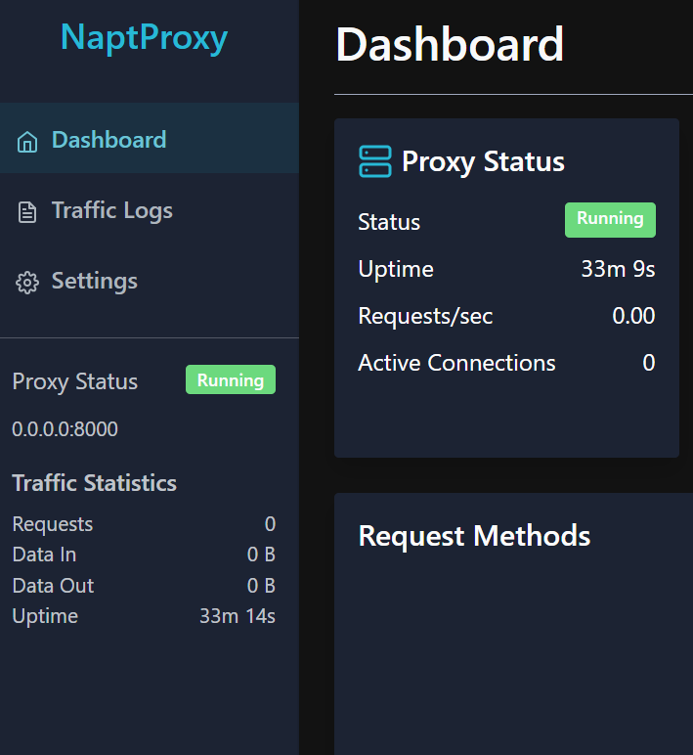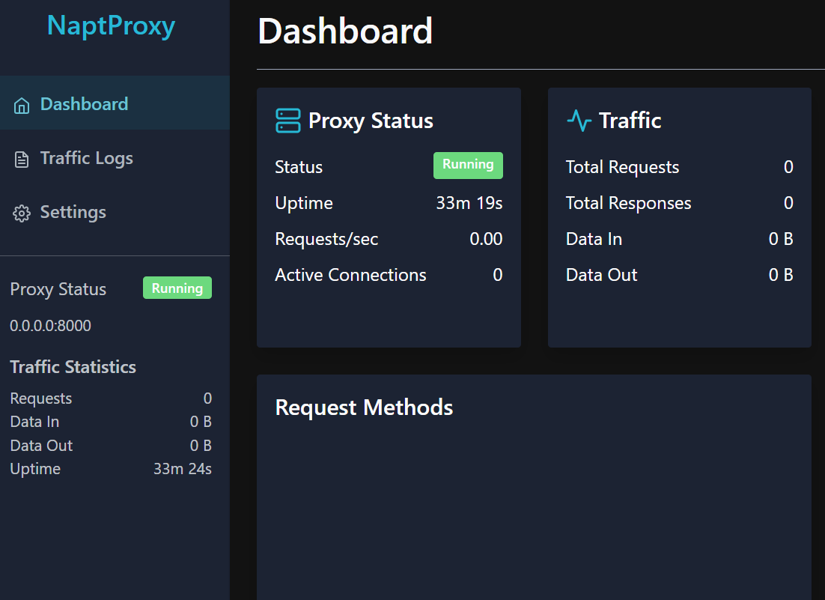
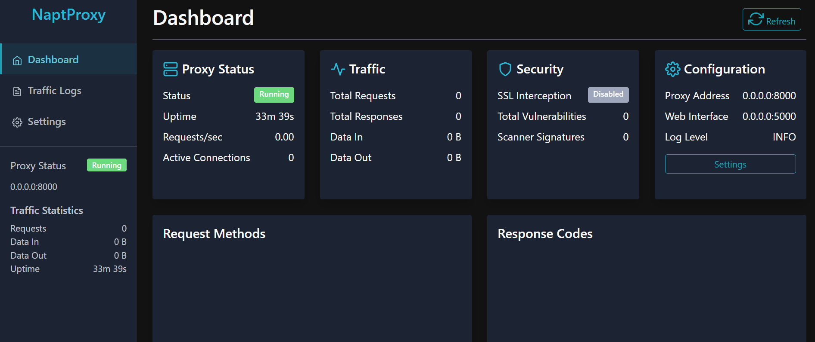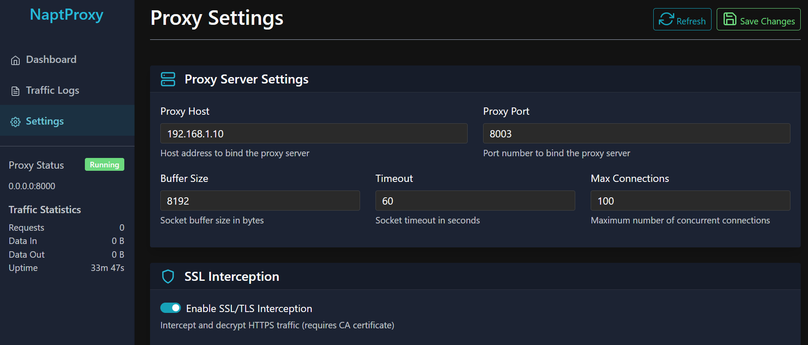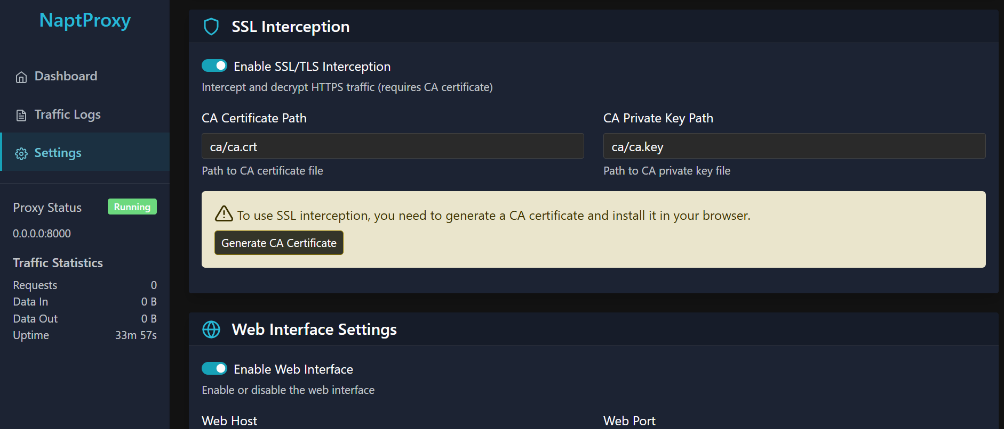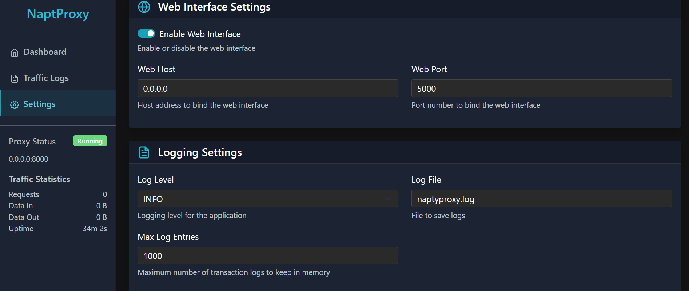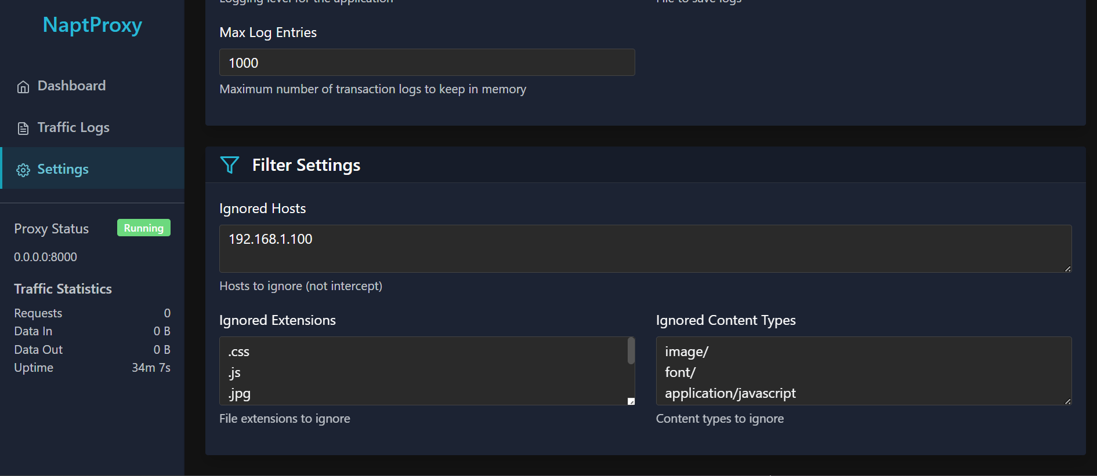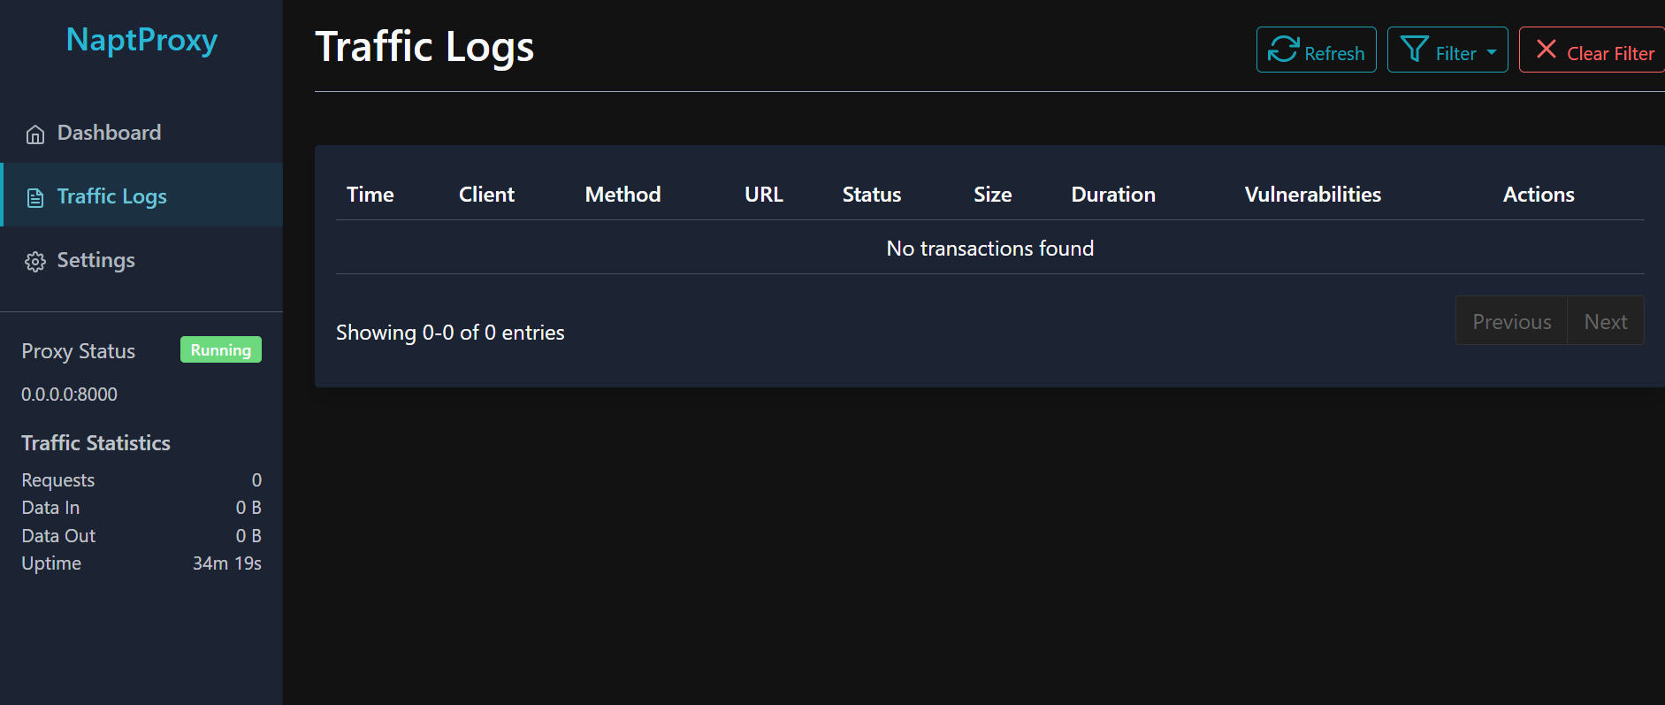

5.3 OUT SCREENS

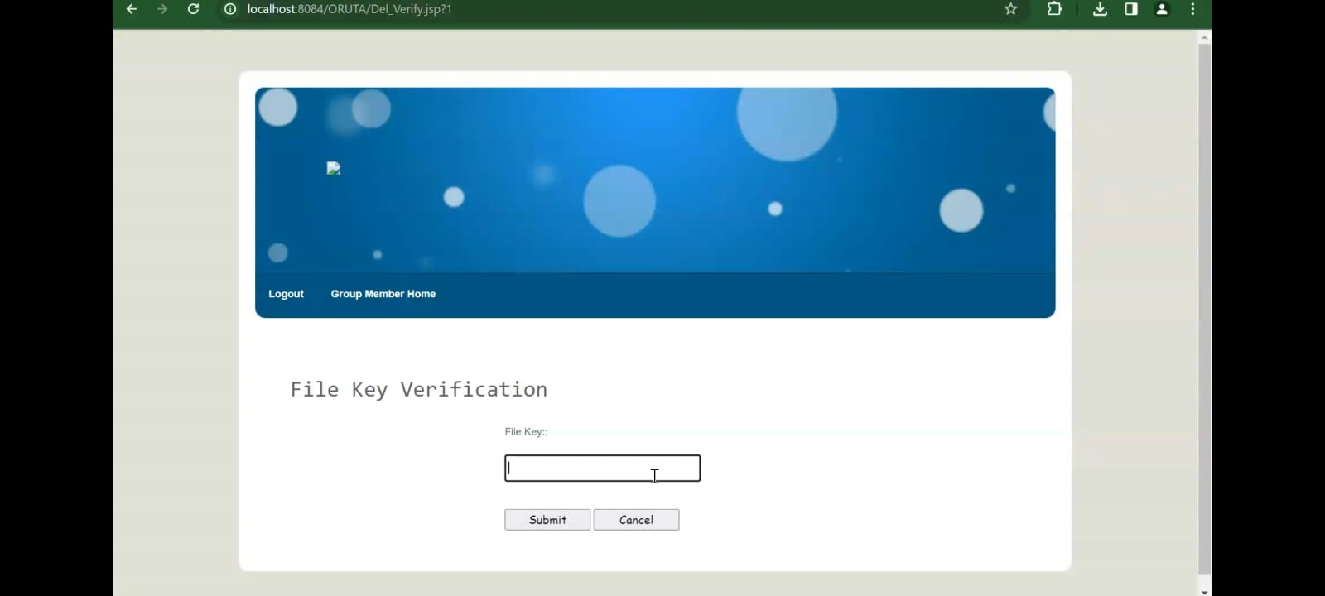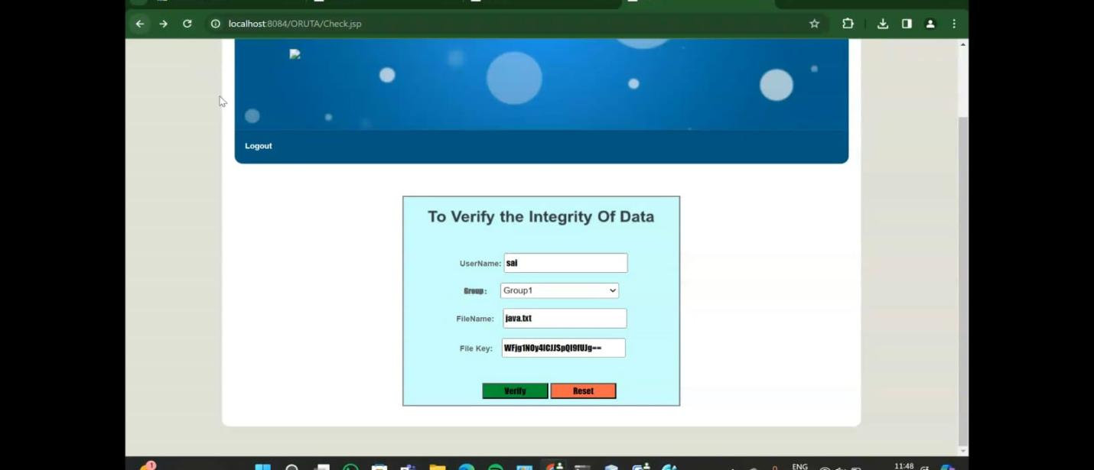
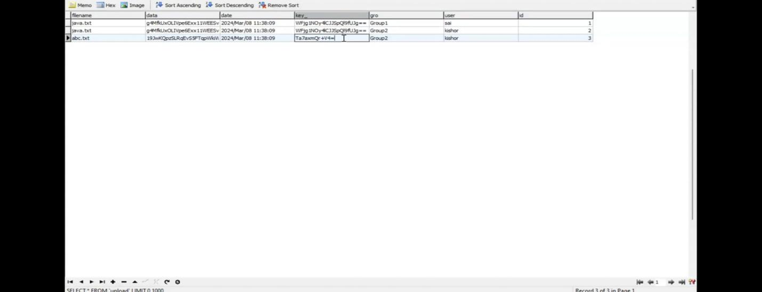



CHAPTER VI

CONCLUSION AND FEATURE ENHANCEMET
In this paper, we propose Oruta, a privacy-preserving public auditing mechanism for shared data in the cloud. We utilize ring signatures to construct homomorphic authenticators, so that a public verifier is able to audit shared data integrity without retrieving the entire data, yet it cannot distinguish who is the signer on each block. To improve the efficiency of verifying multiple auditing tasks, we further extend our mechanism to support batch auditing. There are two interesting problems we will continue to study for our future work. One of them is traceability, which means the ability for the group manager (i.e., the original user) to reveal the identity of the signer based on verification metadata in some special situations. Since Oruta is based on ring signatures, where the identity of the signer is unconditionally protected [21], the current design of ours does not support traceability. To the best of our knowledge, designing an efficient public auditing mechanism with the capabilities of preserving identity privacy and supporting traceability is still open. Another problem for our future work is how to prove data freshness (prove the cloud possesses the latest version of shared data) while still preserving identity privacy.

CHAPTER VII

BIBLIOGRAPHY & REFERENCES
Good Teachers are worth more than thousand books, we have them in Our Department
REFERENCES
[1] B. Wang, B. Li, and H. Li, “Oruta: Privacy-Preserving Public Auditing for Shared Data in the Cloud,” Proc. IEEE Fifth Int’l Conf. Cloud Computing, pp. 295-302, 2012.
[2] M. Armbrust, A. Fox, R. Griffith, A.D. Joseph, R.H. Katz, A. Konwinski, G. Lee, D.A. Patterson, A. Rabkin, I. Stoica, and M. Zaharia, “A View of Cloud Computing,” Comm. ACM, vol. 53, no. 4, pp. 50-58, Apr. 2010.
[3] K. Ren, C. Wang, and Q. Wang, “Security Challenges for the Public Cloud,” IEEE Internet Computing, vol. 16, no. 1, pp. 69-73, 2012.
[4] D. Song, E. Shi, I. Fischer, and U. Shankar, “Cloud Data Protection for the Masses,” Computer, vol. 45, no. 1, pp. 39-45, 2012.
[5] C. Wang, Q. Wang, K. Ren, and W. Lou, “Privacy-Preserving Public Auditing for Data Storage Security in Cloud Computing,” Proc. IEEE INFOCOM, pp. 525-533, 2010.
[6] B. Wang, M. Li, S.S. Chow, and H. Li, “Computing Encrypted Cloud Data Efficiently under Multiple Keys,” Proc. IEEE Conf. Comm. and Network Security (CNS ’13), pp. 90-99, 2013.
[7] R. Rivest, A. Shamir, and L. Adleman, “A Method for Obtaining Digital Signatures and Public Key Cryptosystems,” Comm. ACM, vol. 21, no. 2, pp. 120-126, 1978.
[8] The MD5 Message-Digest Algorithm (RFC1321). https://tools. ietf.org/html/rfc1321, 2014.
[9] G. Ateniese, R. Burns, R. Curtmola, J. Herring, L. Kissner, Z. Peterson, and D. Song, “Provable Data Possession at Untrusted Stores,” Proc. 14th ACM Conf. Computer and Comm. Security (CCS ’07), pp. 598-610, 2007.
[10] H. Shacham and B. Waters, “Compact Proofs of Retrievability,” Proc. 14th Int’l Conf. Theory and Application of Cryptology and Information Security: Advances in Cryptology (ASIACRYPT ’08), pp. 90-107, 2008.

[11] C. Erway, A. Kupcu, C. Papamanthou, and R. Tamassia, “Dynamic Provable Data Possession,” Proc. 16th ACM Conf. Computer and Comm. Security (CCS’09), pp. 213-222, 2009.
[12] Q. Wang, C. Wang, J. Li, K. Ren, and W. Lou, “Enabling Public Verifiability and Data Dynamic for Storage Security in Cloud Computing,” Proc. 14th European Conf. Research in Computer Security (ESORICS’09), pp. 355-370, 2009.
[13] C. Wang, Q. Wang, K. Ren, and W. Lou, “Ensuring Data Storage Security in Cloud Computing,” Proc. 17th Int’l Workshop Quality of Service (IWQoS’09), pp. 1-
[14] B. Chen, R. Curtmola, G. Ateniese, and R. Burns, “Remote Data Checking for Network Coding-Based Distributed Storage Systems,” Proc. ACM Workshop Cloud Computing Security Workshop (CCSW’10), pp. 31-42, 2010.
[15] Y. Zhu, H. Wang, Z. Hu, G.-J. Ahn, H. Hu, and S.S Yau, “Dynamic Audit Services for Integrity Verification of Outsourced Storages in Clouds,” Proc. ACM Symp. Applied Computing (SAC’11), pp. 1550-1557, 2011.
[16] N. Cao, S. Yu, Z. Yang, W. Lou, and Y.T. Hou, “LT Codes-Based Secure and Reliable Cloud Storage Service,” Proc. IEEE INFOCOM, 2012.
[17] B. Wang, B. Li, and H. Li, “Certificateless Public Auditing for Data Integrity in the Cloud,” Proc. IEEE Conf. Comm. and Network Security (CNS’13), pp. 276-284, 2013.
[18] C. Wang, S.S. Chow, Q. Wang, K. Ren, and W. Lou, “Privacy-Preserving Public Auditing for Secure Cloud Storage,” IEEE Trans. Computers, vol. 62, no. 2, pp. 362-375, Feb. 2013.
[19] B. Wang, B. Li, and H. Li, “Public Auditing for Shared Data with Efficient User Revocation in the Cloud,” Proc. IEEE INFOCOM, pp. 2904-2912, 2013.
[20] B. Wang, B. Li, and H. Li, “Panda: Public Auditing for Shared Data with Efficient User Revocation in the Cloud,” IEEE Trans. Services Computing, 20 Dec. 2013, DOI: 10.1109/TSC.2013.2295611. [21] D. Boneh, C. Gentry, B. Lynn, and H. Shacham, “Aggregate and Verifiably Encrypted Signatures from Bilinear Maps,” Proc. 22nd Int’l Conf. Theory and Applications of Cryptographic Techniques: Advances in Cryptology (EUROCRYPT’03), pp. 416-432, 2003.

